-Delete Set null
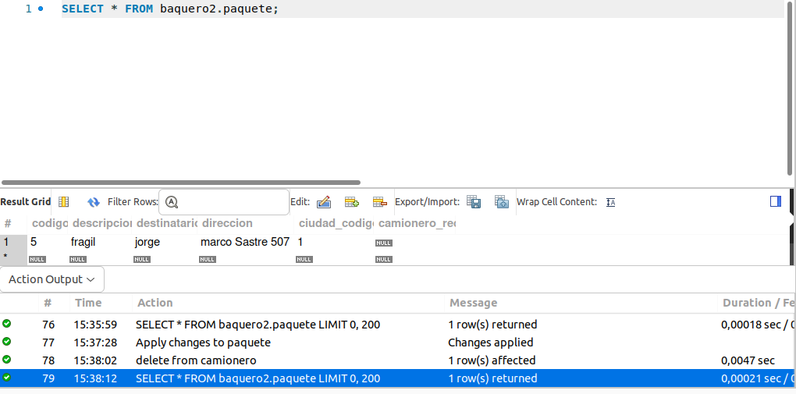
-Delete restrict
-Update restrict
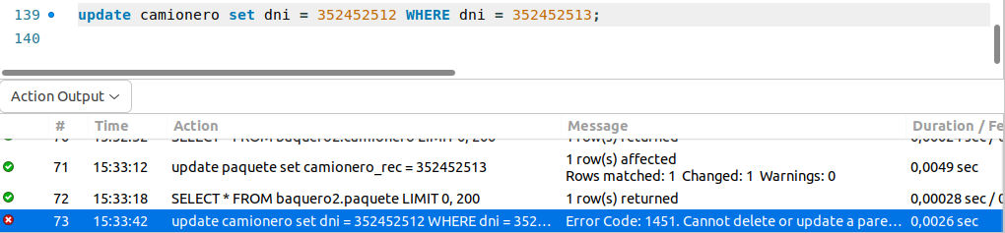
-Update cascade

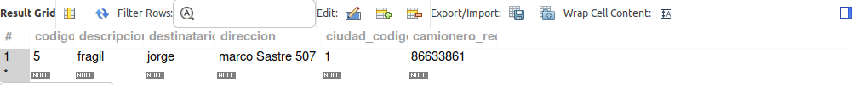
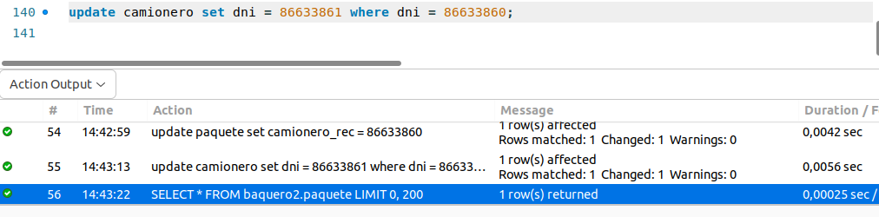

-delete cascade
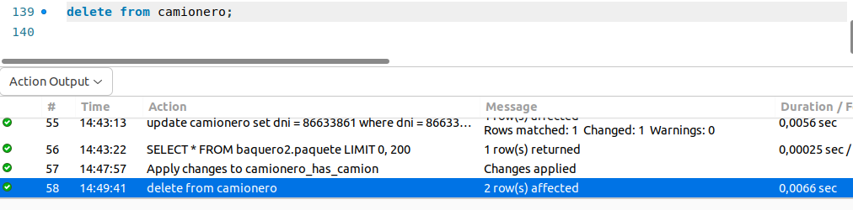
-Update set null

